Title: GUIDELINE , ASCENX DRAWING TEMPLATE, AUTOCAD/PRO-E
Summary: AutoCAD/Pro-E Drawing Template for B & D size Procedure

Name |  | Initial / Date | Distribution Restriction
Prepared by | Hanh Nguyen | 12/06/2010 | This document has distribution restrictions
Approved by | Hoan Le |  | This document has distribution restrictions

Revision | Change ECO # | Originator | Approver | Date
AA | 00004 | Hanh Nguyen | Hoan Le
- OVERVIEW
This procedure use to instruct how to use a template in AutoCAD & Pro-Engineer software for making all Ascenx’s drawings.

- SCOPE
- Provide step by step instructions to use AutoCAD & Pro-Engineer drawing template B & D size for all drawings of Ascenx in AutoCAD & Pro-Engineer software included: layer style, dimension style, text style, block and border & title block…
- All design engineers must follow this procedure to make all drawings of Ascenx.

- DEFINITIONS
APDM: Ascenx Product Data Management
AutoCAD: 2D/3D software from Autodesk Inc.
Pro-Engineer or Pro-E: 3D software from Parametric Technology Corporation.
*.dwt file: Drawing Template file (from AutoCAD)
*.frm file: Format file (from Pro-E file)
PDF: Portable Document Format
MS PowerPoint: Microsoft PowerPoint file
BOM Table: Bill of Material Table
REV Table: Revision Table
Block: All objects which are previous designed and call out from block library to use.
P/N: Part Number
- ROLES AND RESPONSIBILITIES
- All changes to improve for all templates will be done by originator and approved by leader or manager.
- All users must use these templates for all drawings of Ascenx and feedback to person in charge when user need update information to template.
- REFERENCE DOCUMENTS AND WEB ADDRESSES
Use User Guide, Ascenx AutoCAD Layer Standard - Template with
P/N: 510-000005-01-AA to refer more information.

- REQUIRED TOOLS AND EQUIPMENTS
Install AutoCAD & Pro-E software to computer before using these templates for creating Ascenx drawing.

- PREPARATIONS AND WARNINGS
N/A

- PROCEDURE STEPS
Step 1: Get Template files from APDM
Go to link and login:
http://app.ascenx.com/oem/administrator
Note:
Please contact Document Control to have new account to access to APDM. See Figure 1.
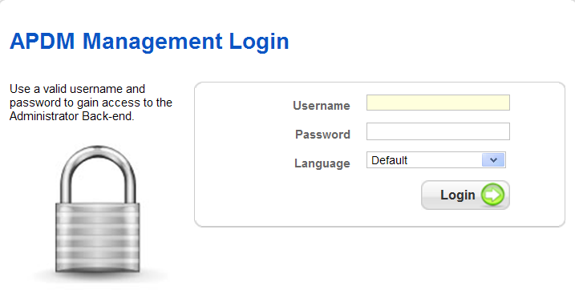
Figure 1
The template files are stored in APDM, AutoCAD and Pro-E library is controlled by Part Number as below:
AutoCAD software:
TEMPLATE, AUTOCAD DRAWING, B/D SIZE, ASCENX with P/N: 525-000002-02-AA
Pro-Engineer software:
TEMPLATE, PRO-E DRAWING, B/D SIZE, ASCENX with P/N: 525-000002-01-AA

Step 2: Make a new drawing by using the Ascenx’s Templates.
2.1 AutoCAD software:
Choose a New drawing icon → Choose template suitable for drawing (B or D size, Sheet 1 or 2) for drawing → Click Open button → Make a drawing. See Figure 4
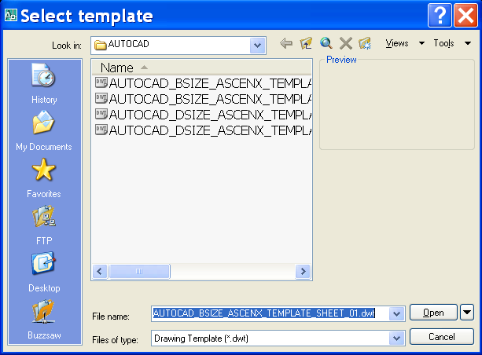
Figure 4
Note:
Remember using suitable layer style, text style, and dimension style for drawing. See Figure 5

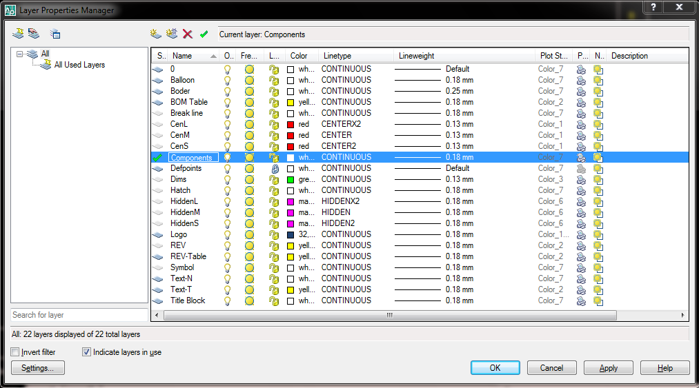

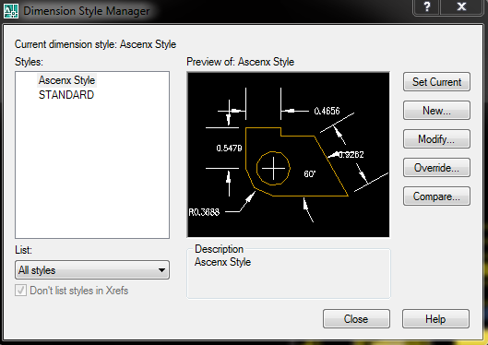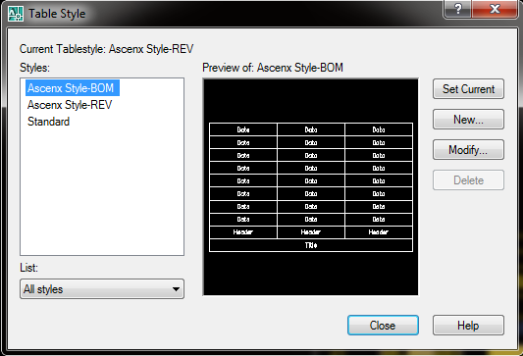

Figure 5

Note:
User should fill in or change information of Title Block before make drawing for part by form (Choose File icon → Drawing Properties → Custom → Save icon to update information) or direct to Title Block. See Figure 6

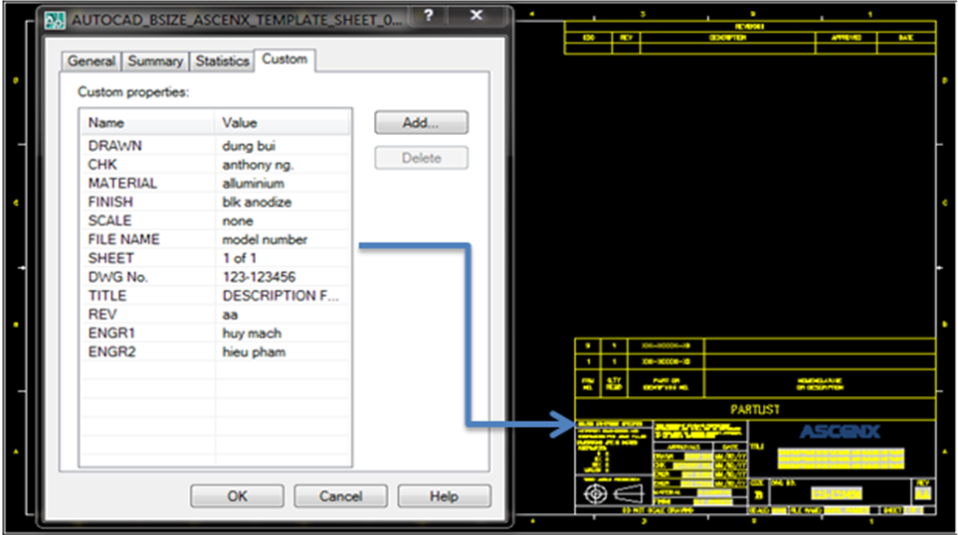
Figure 6

For additional information, refer User Guide, Ascenx AutoCAD Layer Standard - Template with P/N: 510-000005-01-AA
2.2 Pro-E software:
Choose New Drawing icon → select Type (Drawing) → Create Name → Check Use default template.
Pro-E open new window →Choose Empty with format → Browse → choose Working Directory → choose suitable templates (Ex: pro_dsize_ascenx_template.frm) → make drawing. See Figure 7

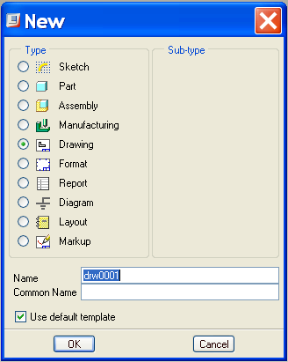+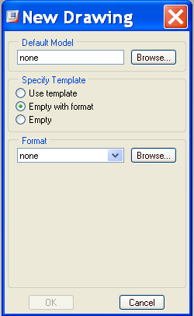

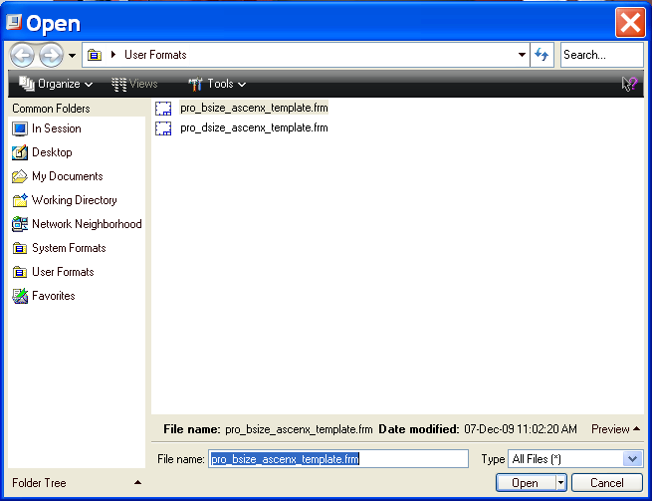

Figure 7

Note:
When software pop up a prompt line to fill information into Title Block user should fill in blank or change all information before make a drawing for part.

- APPENDIX
N/A

